**Change Management**

**Preceptorship Programme**

[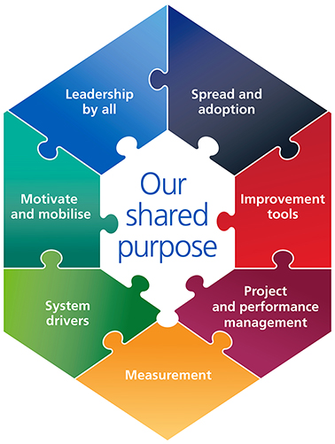](https://www.google.com/url?sa=i&rct=j&q=&esrc=s&source=images&cd=&cad=rja&uact=8&ved=2ahUKEwiA0KmK3IHgAhUEWhoKHRfdAiwQjRx6BAgBEAU&url=https://www.england.nhs.uk/sustainableimprovement/change-model/&psig=AOvVaw1W2QE_aafalncpWz3ZxGWU&ust=1548257841808755)

Lisa Newsum and Julia Telfer

1. **Identifying the need for change**

As a Staff Nurse/Nurse Associate, you may be required to lead on a project of service improvement. You may have seen something in practice you want to change, or you may want to start something new.

|  |
| --- |
| *Think of something you have been given as a project/want to improve/want to introduce.* |
|  |

**Policy:** All national policies include targets for service development and a framework for innovation and leadership. These are driven by your trust policy and the aims for your service.

|  |
| --- |
| *Can you find a national policy which sets targets for your service?*  *Which Trust policy supports this?* |

If you are making a case to improve or introduce something it helps if it is endorsed by organisational policy and targets.

**Service level evidence:** If you have an idea to change something you must find evidence in your service that the change is needed.

Gaps in provision: client, staff, team observation

• Complaints: clients, carers, relatives

• Adverse incidents

• Local and national policy

• Reviews: e.g: C.Q.C.

• Access to resources and expertise

• Evidence based practice

|  |
| --- |
| *What evidence supports your idea/project?* |

**Personal abilities and motivation:**

**What motivated your choice?** • Curiosity • Enthusiasm • Opportunity • Challenges • Availability • Ease

**Personal Qualities**: • Self-belief • Self-awareness • Self-management • Drive for improvement • Personal integrity

NHS Institute for Innovation and Improvement 2007

Acts of leadership can come from anyone in the organisation and as a model it emphasises the responsibility of all staff in demonstrating appropriate behaviours, in seeking to contribute to the leadership process and to develop and empower the leadership capacity of colleagues

NHS Leadership Academy 2012

|  |
| --- |
| *What motivates your choice of the area you would like to change?* |

1. **Devising aims and outcomes and involving others**

To implement change. it is important to have aims and outcomes

**Aims** the areas of change you intend to achieve through your project and which stem directly from the needs of your clients.

• **Outcomes** the changes and effects that actually happen as a result of your work, expected or unexpected, welcome or unwelcome.

• The outcomes you hope to see are all the specific changes that will help you to achieve your aims.

Source: Cupitt, S. with Ellis, J. (2004) Your project and its outcomes

**Examples:**

**Project title**: • Wellbeing Monday. **Aim**: • Enhance the physical wellbeing of residents in an inpatient forensic unit **Outcomes:** • Improve and maintain physical monitoring • Improve physical health awareness of clients • Co facilitate health promotion groups • Regular, planned physical activity

**Project title:** • Learning Disability and Mental Health Awareness: A Pilot study **Aim**: • To raise awareness of learning disabilities in mainstream mental health services **Outcomes**: • To develop a knowledge, skills and attitudes questionnaire for mental health staff around learning disabilities. • To develop pilot training session on learning disabilities for mental health staff • To enable mental health staff to raise knowledge, skills, attitudes and confidence when supporting people with learning disabilities.

**Project title:** • Group work for people with learning disabilities and at risk of mental health problems **Aim**: • To promote mental health and wellbeing for people with learning disabilities **Outcomes**: • Identify people with learning disabilities that are at risk of having mental health problems. • Provide 15 week course using the pack MH Promotion for People with LD • Monitor attendance • Test understanding and satisfaction by using a quiz and evaluation tool

|  |
| --- |
| *Devise aims and outcomes for your potential project* |

**Involving people:**

The people involved in change management are often defined as “stakeholders”

Stakeholders are individuals, groups, coalitions and organisations internal and external to the decision makers and who either affect or who are affected by a services actions, behaviours and policies •

Stakeholder involvement helps determine the full set of consequences and reconciles various interests •

Helps the process of helping people accept the decision and see it in their best interest •

Helps identify options

Jones and Jenkins (2006)

Not involving stakeholders may lead to resistance, lack of support and lack of sustainability. •

Involving them in a “tokenistic” way or “second guessing” what their opinions are can be problematic.

NHS Institute for Innovation and Improvement (2007)

|  |
| --- |
| *Who are your stakeholders?*  *How would you engage them?*    *•What issues do you anticipate?*    *•How would you overcome these?* |

**Motivation and resistance:**

* Misunderstanding about the need for change/when the reason for the change is unclear —
* Fear of the unknown —the risks of standing still are greater than those of moving forward
* Lack of competence change in organizations necessitates changes in skills,
* Connected to the old way —emotional connections to the old way – and that’s not trivial
* Low trust — When people don’t believe that they, can competently manage the change Temporary — When people belief that the change initiative is a temporary
* Not being consulted —Not being allowed to be part of the change
* Poor communication — It’s self-evident isn’t it?
* Changes to routines —whenever change requires us to do things differently Exhaustion/Saturation —People who are overwhelmed by continuous change resign themselves to it and go along with the flow. You have them in body, but not their hearts.
* Change in the status quo —people who feel they’ll be worse off at the end of the change Similarly, if people believe the change favours another group/department/person
* Benefits and rewards — When the benefits and rewards for making the change are not seen as adequate for the trouble involved

|  |
| --- |
| *Can you see any of these issues occurring in your work place? How might people behave?* |

1. **Implementation: making it happen**

This involves the personal qualities to motivate people and the ability to be organised and strategic.

* Project Management has two sides: the technical side, with the project initiation documents, plans and logs. There is also the people management side, with stakeholder engagement, wining hearts and minds and good communication. Both sides are equally important, but some projects fail because effective skills for managing people are failing.
* As an improvement leader you need to be aware that people have different needs and styles of working especially in a change situation. If there is a lack of information a lack of diversity management, individuals can be labelled as “resistant to change”

Institution for Innovation and Improvement (2007)

Timelines and tools for analysis are helpful. They can help you keep projects on track, work to deadlines within the project and within the organisation

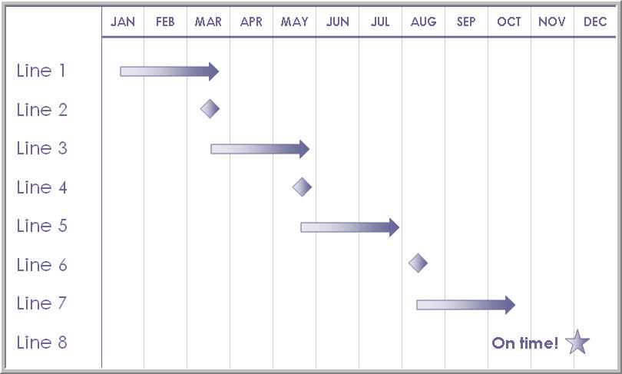

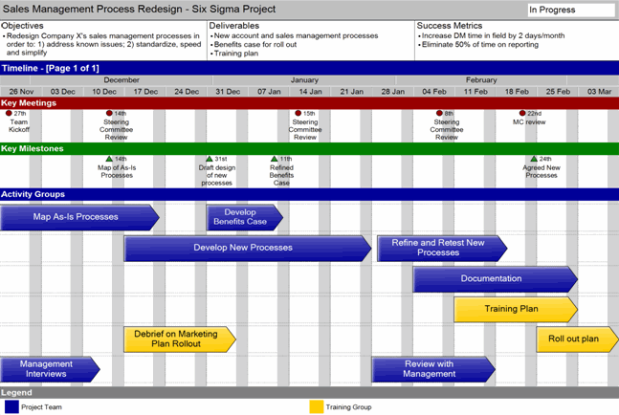

You may wish to use creative visual representations to engage staff at any stage of the project:

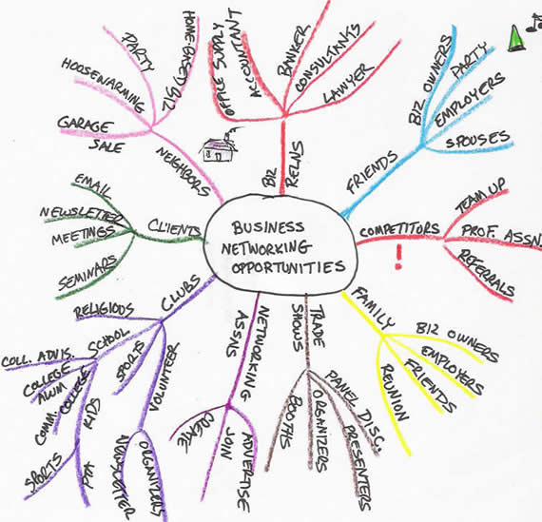

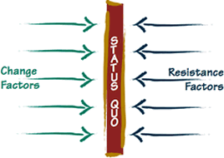

|  |
| --- |
| * *Please complete the project responsibilities and milestone chart for your project.* * *Present to your group members.* * *Summarise the usefulness of these tools.* |

1. **Evaluation and sustainability**

* All initiatives need to fit with wider strategy: this needs to be reflected in the evaluation
* If the information obtained by evaluation fits wider strategy, the improvements are more likely to be sustained
* Are there existing evaluation frameworks that you could utilise?
* Evaluation is directly linked to outcomes
* Develop a plan
* Design is sympathetic to outcomes
* What information do you need to obtain?
* Methods and skills
* Resources: collection, collation and storage
* Stakeholder interest: will the results be viewed or used in a way that was not originally intended
* Framework for representing the results

NHS Institute for Innovation and Improvement (2007)

|  |
| --- |
| *Look at your outcomes. What evidence would you need to collect to demonstrate how these had been met?* |

**Questionnaires:**

Data collection instruments used to collect standardized information

Appropriate when

* you want information from many people
* you have some understanding of the situation and can ask meaningful questions
* information is sensitive or private
* people may be more willing to answer an anonymous questionnaire; may reduce bias

**Focus groups;**

* A focus group is a small group of six to ten people led through an open discussion by a skilled moderator.
* The group needs to be large enough to generate rich discussion but not so large that some participants are left out.
* The focus group moderator nurtures disclosure in an open and spontaneous format.

The moderator’s goal is to generate a maximum number of different ideas and opinions from as many different people in the time allotted

Observation:

* Observation of practice in the context of this study is a tool that enables evidence to be gathered directly about practice expertise, as well as providing a rich source of material for exploration and critique within action learning and critical companion relationships.

Manley et al (2004)

**Audit:**

The Trust has an excellent quality improvement department – please check The Ox for more details

**Sustainability:**

Maintaining the health benefits of a programme over a long period

Continuation of the service or programme activities within an organisational structure

Building the capacity of a recipient community

NHS Institute for Innovation and Improvement (2007)

|  |
| --- |
| *Identify structures and strategies that could maintain your change.* |

**References:**

Jones R and Jenkins S (2006) Managing and Leading in the Allied Health Professions. Radcliff Publishing

Manley K Hardy S, Titchen A, Garbett R, McCormack B (2004) Changing Patient’s Worlds Through Nursing Practice Expertise RCN Publications

NHS Institute for Innovation and Improvement (2007) Process Mapping, analysis and redesign. NHSI

<https://www.leadershipacademy.nhs.uk/>